**Inspirations**

Our inspirations were key to the design process of this project. One of the first tasks the group performed was to simply name a game they loved, regardless of age or system, and why. Key elements and features of these games were then noted down, and the team worked to include several of these ideas in the final project. Series raised included:

**Ratchet and Clank:**

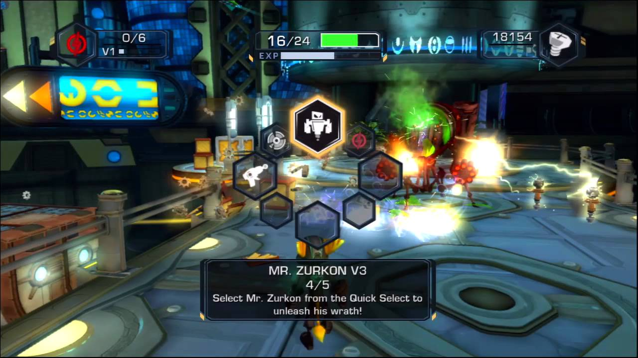

Figure - Ratchet and Clank: A Crack in Time (Axiom City)

A major point of conversation was the items and unlock system involved in Ratchet and Clank. The quick switching of gadgets, the 3D platforming and the combat involving different types of enemies, all of which had strengths and weaknesses, was a major appeal to the group.

Not only would designing several gadgets each be an interesting design activity, but the series, that has gone without a release for nearly four years, is nostalgic for our generation, and many people crave a new R&C release.

**Specific Concepts**

* Gadgets and weapons
* 3D platforming
* Quick Select
* Movement upgrades

**Sonic:**

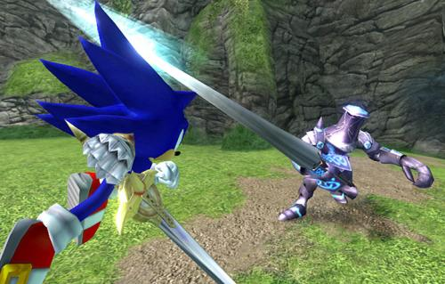

Figure - Sonic and the Black Knight

Sonic's fast-paced gameplay was a large nostalgia factor for the team, and while recent 3D sonic games haven't hit the mark for critics, team members felt that implementing a Ratchet and Clank-style gadget system into the faster sonic gameplay could lead to an interesting new idea.

It was mentioned that Sonic games had already explored a gadget-based system, both ‘Shadow the Hedgehog’ and ‘Sonic and the Black Knight’ became a research focus. In the case of ‘Sonic and the Black Knight’ the gameplay relies on using Excalibur, a sword, while moving at Sonic’s trademark breakneck speed. While in ‘Shadow the Hedgehog’ the player can wield a variety different weapons while moving equally as fast.

The mix of gameplay intrigued the team, and we began to explore further possibilities of the combination. The challenge design in which beating a level was considered a success, yet better scores could be gained by completing it faster, also intrigued the team.

**Specific Concepts**

* Fast paced action
* Momentum in a 3D environment
* Combat skills
* Movement upgrades
* Medieval theme

**Celeste:**

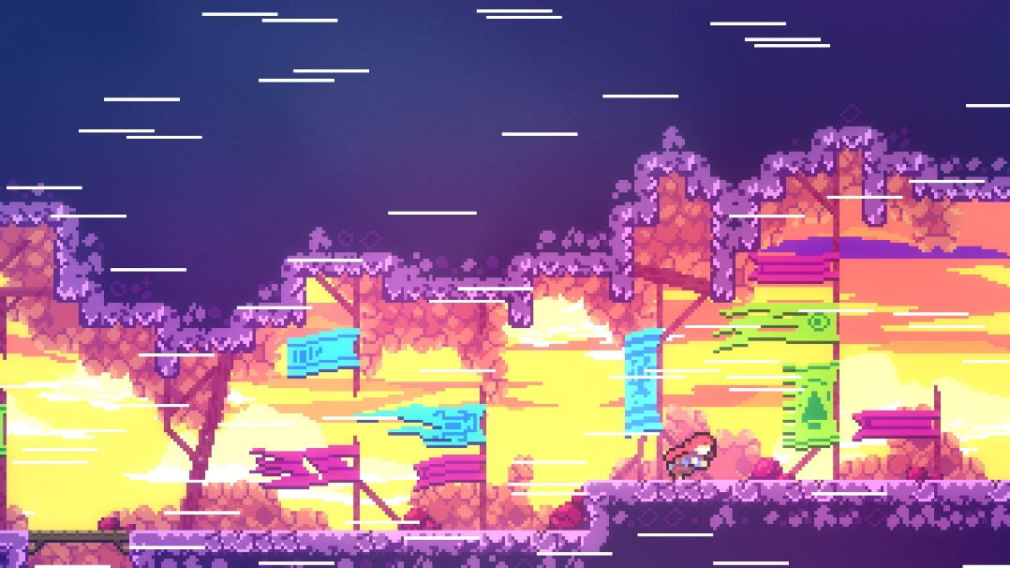

Figure - Celeste (Top of Celeste Mountain)

Celeste has had a major influence online for an indie game, due to it being one of the first easily accessible speed running games. Many of our team members have been interested or even involved in the competitive and speed running communities of games in the past, and it was agreed that being able to complete a game quickly and skilfully is a very satisfying feeling for the player that we would like to replicate.

Combined with the Sonic rating system for completing levels, mastering certain levels in celeste-style speed gameplay could be a high-tension, high-skill situation for the player.

**Specific Concepts**

* Tight controls
* 2D Platforming
* Movement upgrades
* Colourful aesthetics

**Mario Kart**

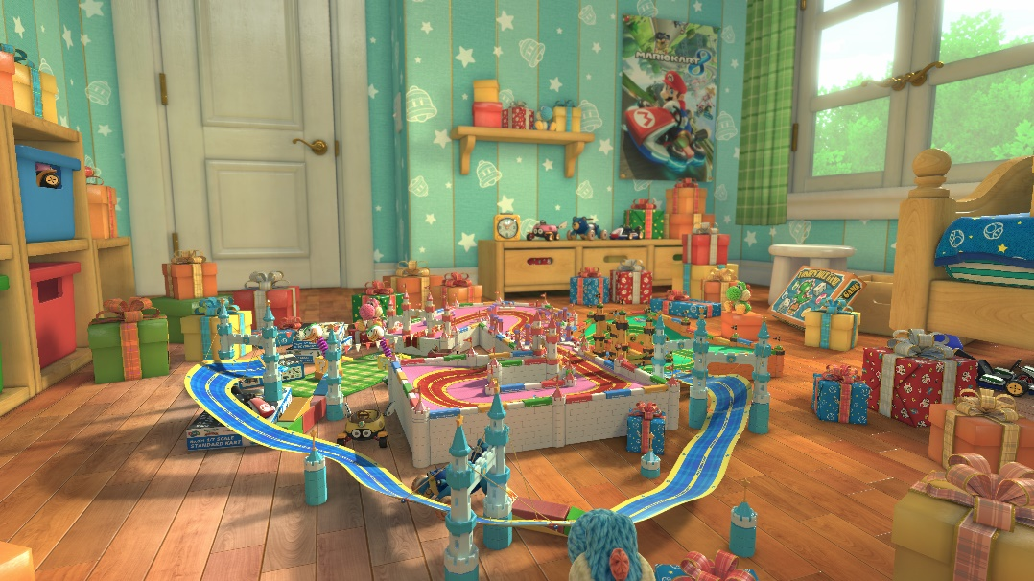

Figure - Mario Kart 8 Deluxe (Ribbon Road)

Mario Kart has been a staple party game for many generations, and the simple racing gameplay has enthralled audiences for years. The team's focus, having discussed Celeste's influence when completing games quickly, turned to the classic speed game- racing.

While the kart racer gameplay of Mario Kart wasn't inspiring to the group, the tracks and levels were. Each Mario Kart track has a unique aesthetic to it, using Ribbon Road (Mario Kart 8) as an example that the team analysed, and the track is often so interwoven into the environment you forget it is there. The shortcut system also appealed to the team, with hard-to-perform but quicker options being available to the player, with potential time loss should they fail.

The risk/reward system of these shortcuts felt like it would complement the speed influence of Celeste and Sonic's level scoring system well, as higher-skill players could easily set even better times if these options were available to them.

**Specific Concepts**

* Time based challenges
* Racetrack levels
* Theme of bedroom and toys
* Colourful aesthetics